CDOT user manual

Android Part

V 0.1.0

2016.04.09

Contents

Login 2

Register 3

Newest Observations 4

User Profile 6

Reset Password 7

Observation History 8

Upload Observation 9

Search Observation 10

Observation Detail 11

Delete Observation 13

# Login

Login

This is the first screen you see when you first time use the app. You can login with your user name and password. You just need to login once and would be automatically login next time. If you don’t have an account, you can click register button to request an account.

You could also choose login later to go to use our search function.

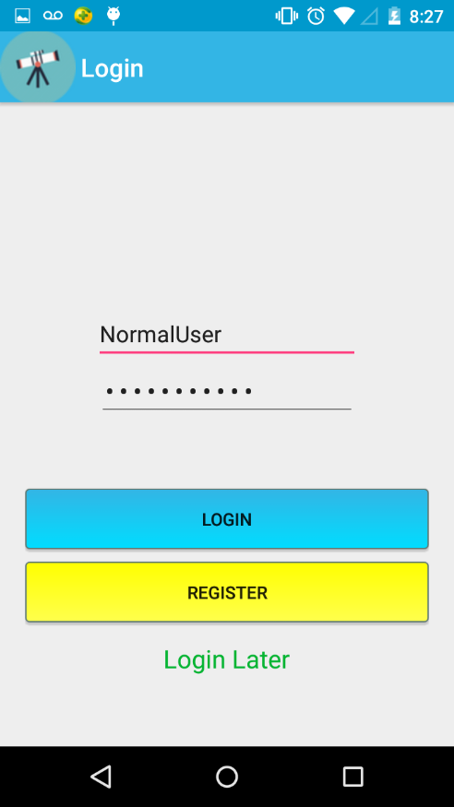

# Register

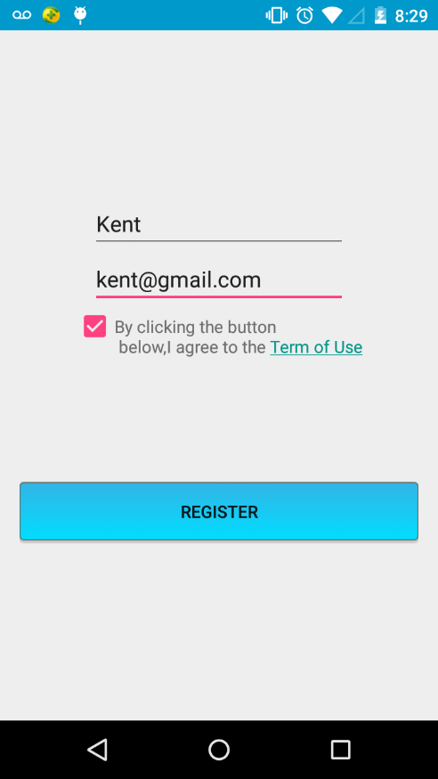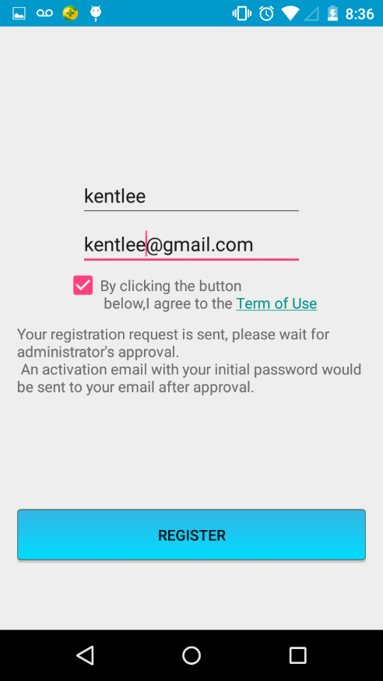

Register

Users can enter the user name and the email they want to register with to send a request.

The request is approved by administrator so it may take a while to process your request.

If the user name or email is already used by others, you need to use another one. If successfully register, you would see a message like the one in the second screen shot.

# Newest Observations

Newest Observations

This is the default screen if user already login, or user could choose login later to come to view the newest observations uploaded.

User could click in any of the post to view the detail of the posts.

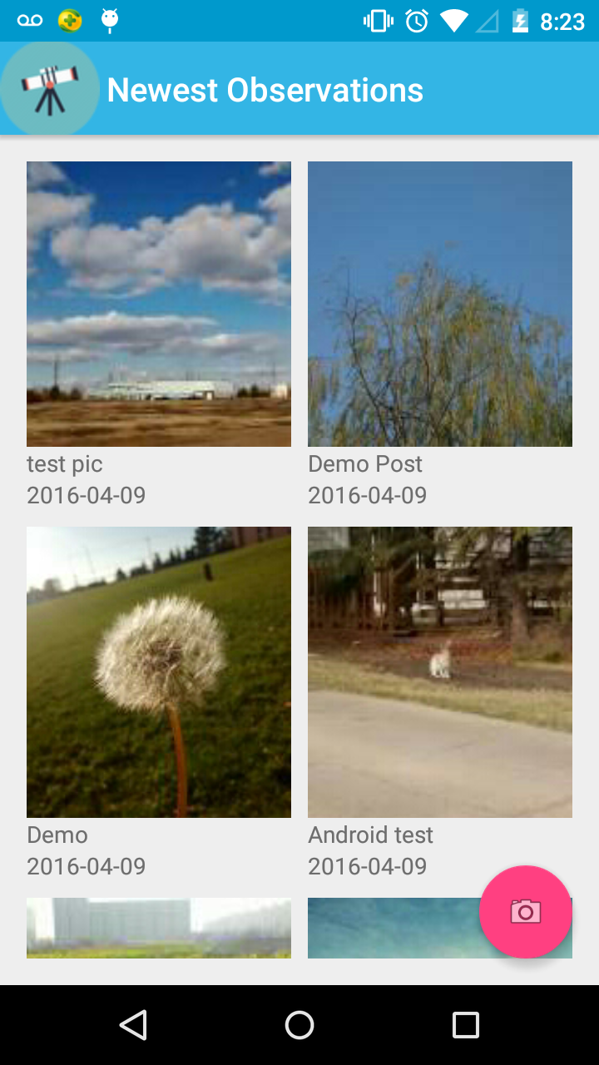

Unauthorized User:

User could click the app icon on the top left corner or swipe to right from the left edge of screen to show the sliding menu. The sliding menu provides several entries to other activity.

The items are different for authorized and unauthorized users.

User could also click the red floating button on the bottom right corner to upload observations.

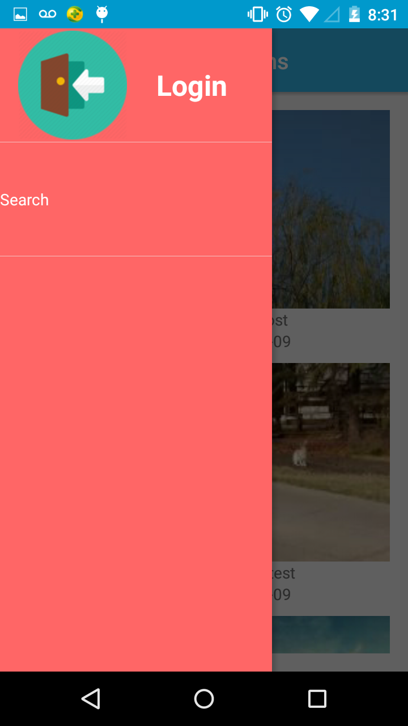

Authorized User: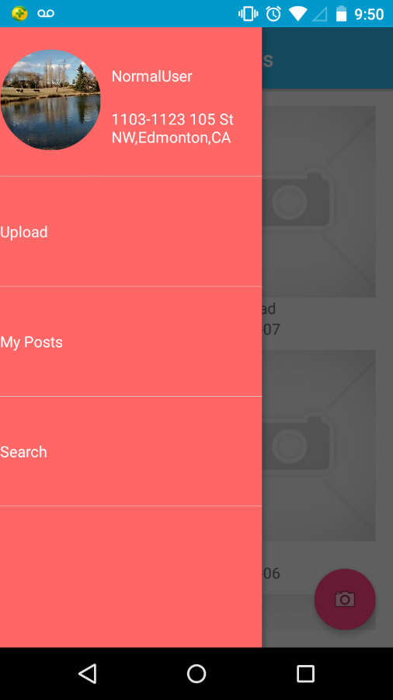

# User Profile

User Profile

User could go to view and edit user profile from the entry in sliding menu.

User could click the profile image to upload a new image. User could also edit user name and address 1, 2. But user could not change email.

User could also logout, change password and go to view observation history by clicking “My Observations”.

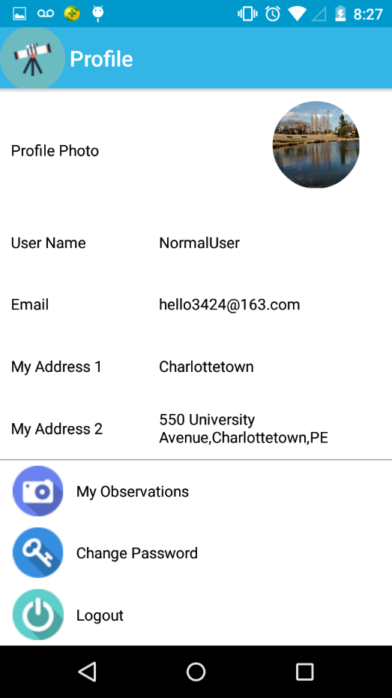

# Reset Password

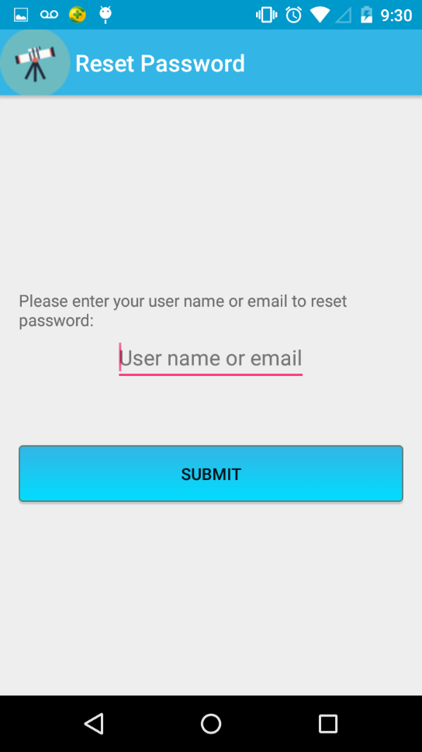

Reset Password

User could send a request to reset password here. User would receive an email with the reset password link in it.

# Observation History

My Posts

User could view observation history here. Click one of the items to view observation in detail.

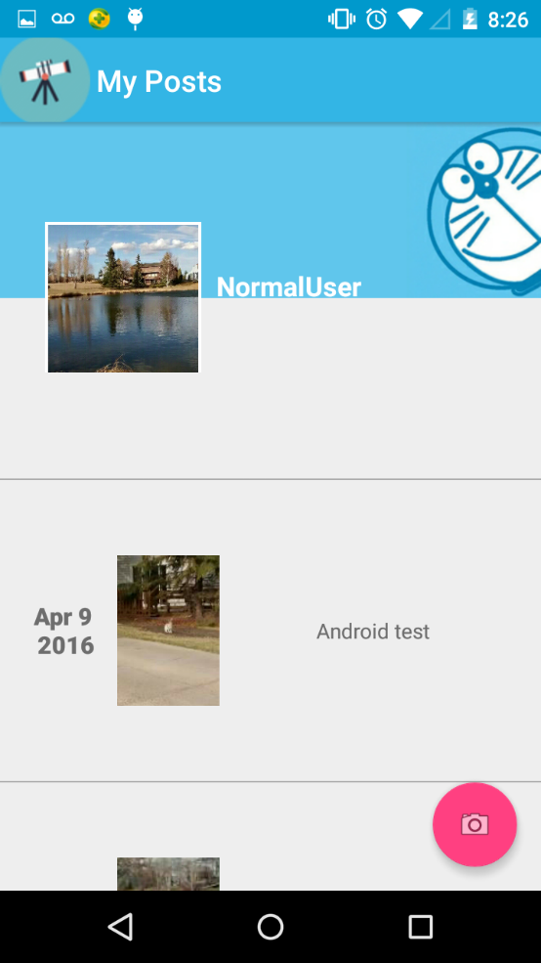

# Upload Observation

Upload Observation

User could upload observation information include record name, title, image, description, date and location.

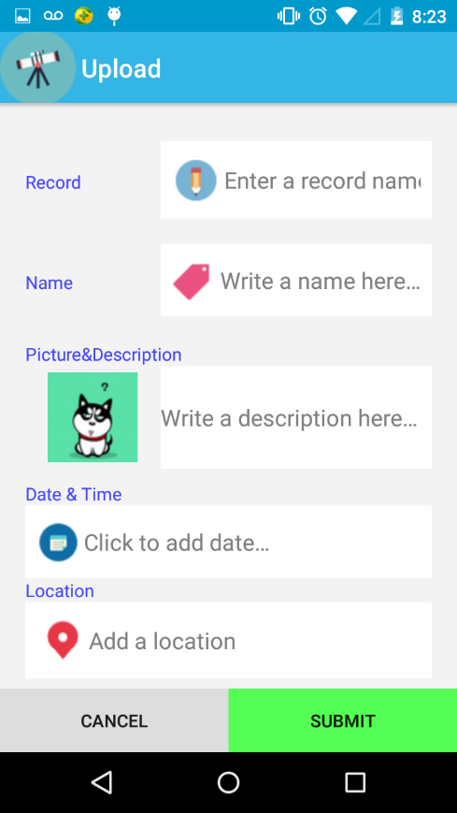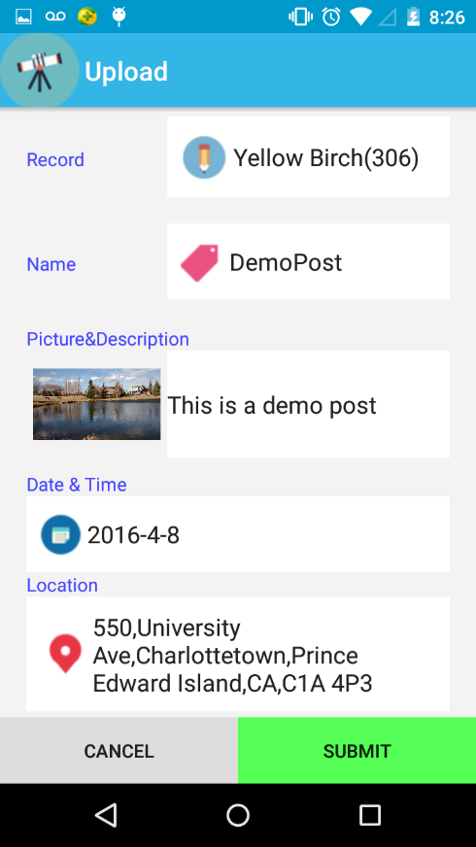

# Search Observation

Search Observation

User could search observations by category, record name, the area with a user specified radius and a date range.

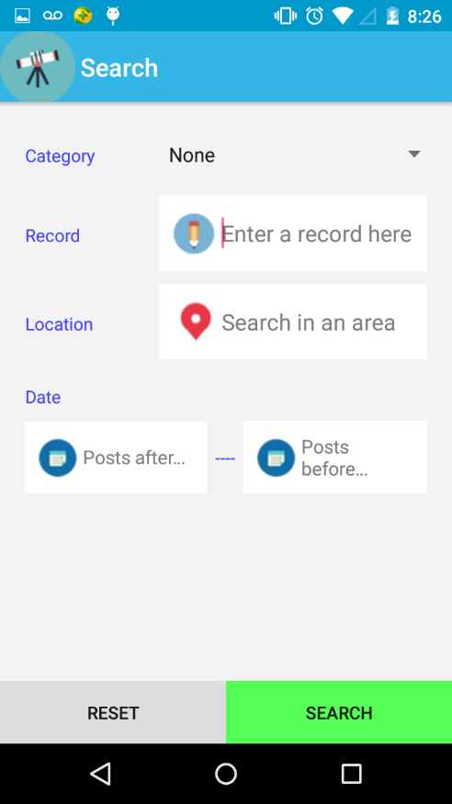

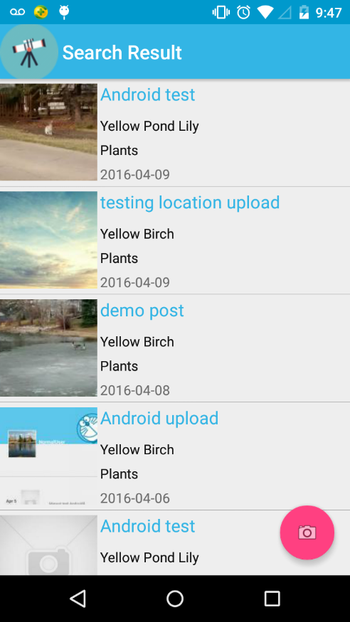

# Observation Detail

Observation Detail

User could view observation details include title, record name, description, date and location.

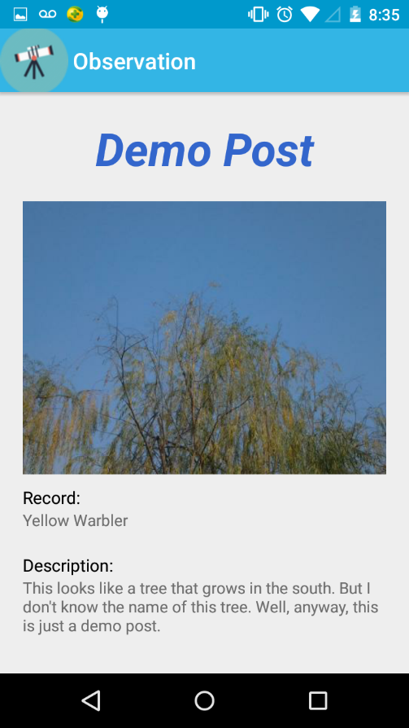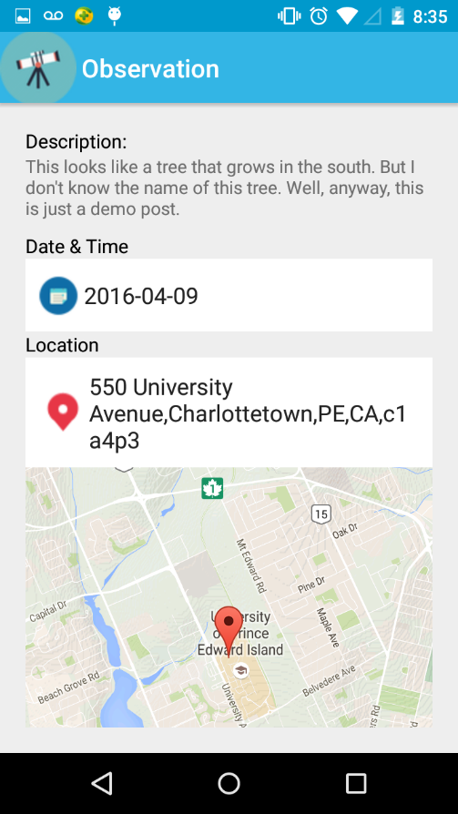

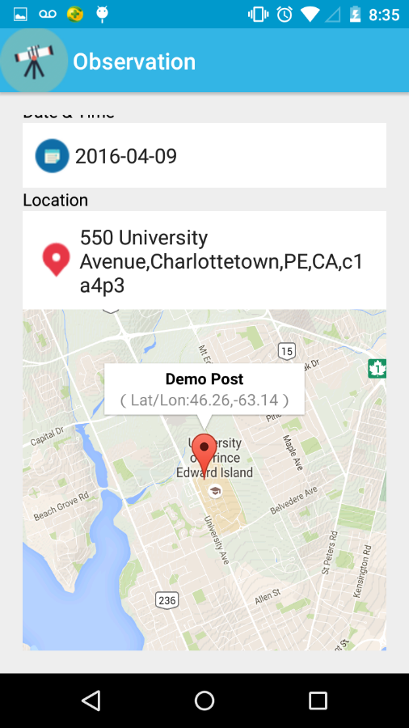

User could click on the marker on the map to see exact latitude and longitude of the location.

# Delete Observation

Delete Observation

User could delete own observation by clicking the delete button on the top right corner.

